PRE TREATMENT INFORMATION AND ADVICE
Please send me the following information and image 2 working days before treatment to allow me to complete the comfort and posture assessment.
For each of the 20 questions, please put a ‘Y’ under the number which most accurately represents your dog over the last 2 weeks.

GALEN MYOTHERAPY COMFORT SCALE  Dogs name:  Dog’s age in yrs and months: | 3 = NO | 2 = RARELY | 1 = SOMETIMES | 0 = CONSISTENTLY
A. PHYSICAL
1. Does your dog show signs of being stiff when getting up?
2. Has your dog stopped jumping onto furniture or into cars?
3. Does your dog groan when they lie down?
4. Does your dog walk into objects/people? i.e. become clumsier
5. Does your dog sit or lie down occasionally during a walk?
C. BEHAVIOURAL
1. Does your dog scratch an itch on their body daily?
2. Does your dog lick their feet, legs or body daily?
3. Does your dog chew/gnaw/nibble their feet, leg, body or tail daily?
4. Does your dog find it difficult to stretch out both their back legs, behind them?
5. Has your dog stopped wagging their tail fully?
D. EATING AND DIGESTION
1. Does your dog have anal gland problems?
2. Does your dog move when defecating?
3. Does your dog have any skin disorders?
4. Has your dog stopped chewing/or are they chewing differently?
5. Does your dog have regular tummy upsets (loose stools)?
E. OTHER INDICATORS
1. Does your dog have a dry nose?
2. Does your dog prop their head up/or hang their head off something, when they rest/sleep?
3. Does your dog lie mainly on one side?
4.When standing still does your dog shift their weight from side to side?
5. Does your dog have areas of dead or dry coat?

IMAGES
To help me assess your dog effectively please send me the following 4 images: I know it can be hard photographing your dog, but good quality pictures of your dog in these positions, means my pre assessment of you dog is accurate.
1. Behind view | 2. Front view | 3. Overhead view | 4. Side view
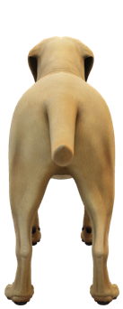 | 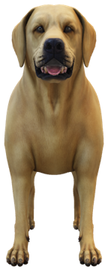 | 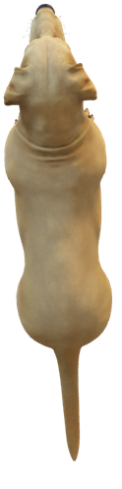 | 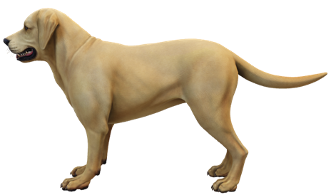

Please could you also send me the following videos
- A walk from behind (off lead if possible)
- A walk from each side (if possible)
- Your dog running
- Your dog defecating and urinating
- Your dog eating their meal
If easier, you can WhatsApp these to me on 07941427336 or WeTransfer is a good way to send large files for free.

The following information is for you to look through before your dog has their Galen Myotherapy treatment
Thank you for using Galen Canine Myotherapy as a treatment for your dog. The following information is things to think about and consider the first session.
- If your dog is unwell it is not appropriate to treat so please contact me and we can rearrange
- Please do not feed your dog up to 2 hours before they come for a Myotherapy session. This is to prevent any possible digestion problems.
- Please do not use any ‘spot on’ flea, tick or worm treatments as I will be most likely working over the area that they have been applied.
- Please allow your dog some time before treatment to have a walk about outside and empty their bowels and bladder if necessary!

What to expect from the first session
There is no straightforward answer to this; every dog is different. The fundamental principle however of how I work as Galen Myotherapists is always giving the dog choice. Please bear in mind that this is the dog’s treatment and if it is new to them it may feel unusual, strange and even uncomfortable at times. I work with the dog therefore the dog is in charge of their body at all times. I will not hold a dog down or stop a dog from moving away from the treatment space if he/she needs some time out or thinking time. Some dogs may let me treat for 30+ minutes straight away whereas others may initially tolerate much less; this is ok and normal! I want this to be a positive experience for your dog and I want to form a bond and connection with them both at the first session and for the future. For your dog’s treatment to be successful, they must trust me. I will therefore not overstep their boundaries of what they are happy to let me do and what they are comfortable with. This will ensure that your dog has a positive treatment, leaves on a good note and will want to come back for further treatments.
I very much look forward to meeting you both.

Please bring a bed/blanket for your dog. We don’t use treats or toys as part of the treatment as the dog will tend to focus on this rather than the treatment itself.
We generally find that your dog will need 3 – 4 treatments at regular intervals to affect a change for them.

